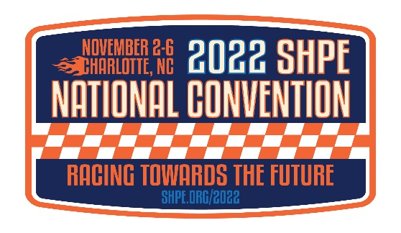
Event Management & Official Contractor List

SHPE Event Management Contacts
Exhibit Sales & Sponsorship  - Including operations & logistics of career fair/interview booths | exhibits@shpe.org
Corporate Relations | partnerships@shpe.org
Finance | finance@shpe.org
Events Team | events@shpe.org
Registration | registration@shpe.org
Workshops | workshops@shpe.org

Official SHPE Contractors
Warning: If you are contacted by a company that is NOT on this list, they are NOT working on behalf of the show. There are several companies that will lead you to believe they are working for the show but that is NOT the case.
Please contact Exhibit Management to alert us of any vendors using these tactics.

Repeat Offenders: Housing vendors, list rental companies, AV services and shipping services.

Decorator/General Contractor: | Freeman | P: 888-508-5054
 |  | P: 512-982-4186
Link to Freeman |  | F: 469-621-5609
 |  | E: exhibitorsupport@freemanco.com
 | Services: | Discount Deadlines:
 | Furnishings | 10/05/2022
 | Flooring | 10/05/2022
 | Installation & Dismantle | 10/05/2022
 | Material Handling | 10/05/2022
 | Signs & Graphics | 10/05/2022
 | Audio Visual | 10/05/2022
 | Booth Cleaning | 10/05/2022
 | Exhibit Transportation
 | Outbound Shipping
 | Advance to Warehouse | Receiving date begins - 10/3/22  Deadline date -10/26/22
 | Direct to Show Labels | CANNOT be delivered before 11/2/22
Rigging  Encore (exclusive in house) | Rigging Order Link | E: william.dail@encoreglobal.com  P: 704-339-6183
Business Center: | The UPS Store Charlotte Convention Center | P: 704-339-6036
Hours:  M-F: 9:30am-5:30pm  Sat: 11:00am-2:00pm | 501 S College St. | E: store6958@theupsstore.com
Sunday - Closed | Charlotte, NC 28202 | Near College St. Entrance
Facility: | Charlotte Convention Center | P: 704-339-6000
 | 501 S College St.
 | Charlotte, NC 28202 | Career Fair / Exhibits- Halls B & C  Interview booths – Hall A
Food & Beverage: | Charlotte Convention Center | P: 704-339-6061
 | 501 S College St | E: sales@charlotteconventionctr.com
Link to menus | Charlotte, NC 28202 | Deadline: 10/12/22
Floral: | TLC Florist | P: 770-507-6777
 | 121 Pine Dr | F: 770-474-4676
Link to Floral | Stockbridge, GA 30281 | E: order@tlc-florist.com
 | www.tlc-florist.com | Deadline: 10/17/22
Housing/Hotel Reservation: | RHS | P: 903-736-6008
 | ResQuest Hotel Services | E: shpe@resquest.com
Link to Housing
Lead Retrieval  Link to Ordering | Custom Registration Inc.  PO Box 668  Arlington, TX 76004 | P: 817-277-7791  F: 817-277-7616  Deadline: 10/24/22
Security: | Show Pros Entertainment Services | P: 704-339-6140
 | Charlotte Convention Center | F: 704-339-6723
Link to Security | 501 S College St. | E: Ryder.Burger@showprostaff.com
 | Charlotte, NC 28202 | Deadline: 10/17/2022
Telephone & Internet: | Smart City | P: 888-446-6911
 | 5795 W. Badura Ave. Suite 110 | E: customerservice@smartcitynetworks.com
Link to Wifi-Internet-Telephone | Las Vegas, NV 89118 | https://orders.smartcitynetworks.com
 | www.smartcitynetworks.com | Deadline: 10/14/22
Utilities (Electrical & Plumbing): | Smart City | P: 888-446-6911
 | 5795 W. Badura Ave. Suite 110 | E: customerservice@smartcitynetworks.com
Link to Utilities | Las Vegas, NV 89118 | https://orders.smartcitynetworks.com
 | www.smartcitynetworks.com | F: 702-943-6001
 |  | Deadline: 10/14/22

