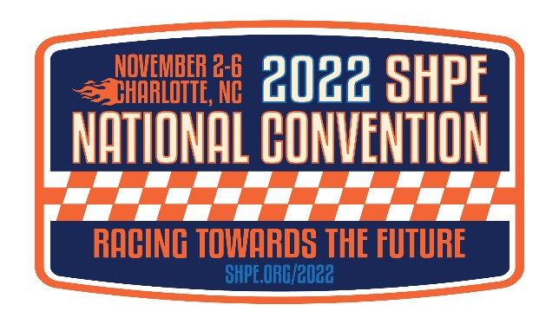
Greetings SHPE National Convention Sponsors!
Exhibitor registration is officially open!
Please read through these instructions prior to registering staff/recruiters for the event.
All individuals must self-register.
Registration Deadline: October 21, 2022
During the registration process, individuals will self-register with the promo code by registration type (see below). The code is only valid for the allotment of registrations included in your sponsor level and any additional you may have purchased.
Please distribute the promo codes only to those individuals that will be participating in the National Convention.
Badge types
Full Convention:
Access to all programs and events (except for ticketed functions) and the career fair/interview booth expo floors

Career Fair Only:
Access to the career fair and interview booth expo floors

Full Convention Allotment:
Promo Code for Full Convention:

Career Fair Only Allotment:
Promo Code for Career Fair Only:

Registration Link:
https://SHPE.customreg.net/register/0a766b34-e337-4d17-9660-3e8ef57acab1

Questions/Support:
Registration: registration@shpe.org
Career Fair: exhibits@shpe.org
SHPE Membership: membership@shpe.org

